6/30/2019

Kyer Potts

30003389

Scripting AT2.1

Analysis and Project Design Report

Table of Contents

Development Frameworks 1

Arduino 1

Microsoft Visual Studio 1

Object Model Diagram (C#) 1

Library Code Requirements 2

C# Libraries 2

System.IO.Ports 2

Arduino Libraries 2

Adafruit Sensor Master 2

DHT Sensor Library Master 2

Testing Requirements 3

Iterative SDLC Testing 3

Testing Methodology 3

Testing Plan 3

References 4

# Development Frameworks

## Arduino

The Arduino platform consists of both an electrical circuit board and the Arduino programming language to implement functions and perform tasks with certain premade circuit board solutions. Arduino was originally created at the Ivrea Interaction Design institute as an easy, cheap tool to allow students to create fast working prototypes for a broad range of projects. All Arduino boards and, the programming language and libraries are open source, making it a powerful resource for students and home technology enthusiasts. (Arduino, 2019)

The simple format and form of Arduino makes it an ideal choice of board solution for this project.

## Microsoft Visual Studio

Visual Studio is a popular integrated development environment that runs on the Microsoft .net framework (Microsoft, 2019). The IDE is a useful tool in the creation of a wide range of computer programs, websites, web apps, mobile apps, interfaces and web services (Wikipedia, 2019).

As a platform, Visual Studio integrates and operates with a wide range of programming languages, most notably Microsoft’s object orientated language C#. It provides features for managing and writing code, debugging, form interface design, refactoring, code clean up, syntax validation and incorporates IntelliSense features. These components and features make Visual Studio a powerful creative device, which is why it will be used to design the interface and connection components of this project.

## Object Model Diagram (C#)

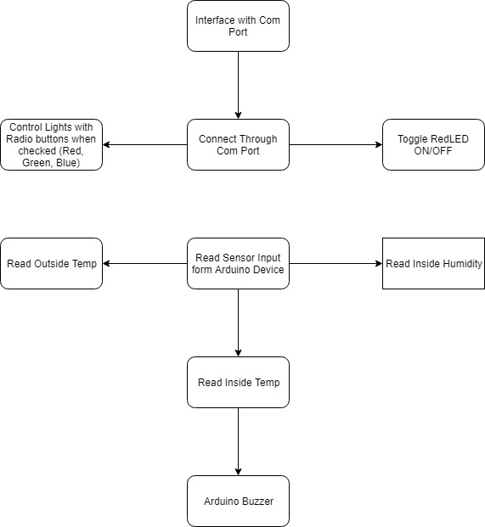

# Library Code Requirements

## C# Libraries

### System.IO.Ports

This library is used to access COM ports to interface with the Arduino board device. It will be implemented during construction of the code and added into the source files once the C# program has been compiled. It is an open source library. It allows the C# code to access a serial port (in this case a USB port) to interface directly with a device plugged into the designated USB port.

## Arduino Libraries

### Adafruit Sensor Master

This library is used to split data streams from read in sensor into single events. The library is implemented when the sketch is uploaded to the Arduino device. It is an open source library, the code can be freely edited and supplemented. This library was chosen to allow multiple values from individual sensor reads to be split into separate read values for the purposes of display.

### DHT Sensor Library Master

This is a supplementary library to Adafruit Sensor Master created for DHT series of low-cost temperature/humidity sensors. It is implemented at the beginning of the sketch to allow use of the DHT data type within the code. The library was chosen to allow specific access to the DHT sensor and output the reading values in a printable form.

# Testing Requirements

## Iterative SDLC Testing

The iterative approach to software development is a departure from the Waterfall model. Once requirements have been defined, the software is developed in incremental builds. This will allow for software to be developed quickly, tested and implemented, with subsequent versions refining and adding additional features to the project. Iterative testing occurs within each incremental build before subsequent implementations. To test the project at each iteration of the build, testers will need updated and well-defined requirements for newly added functionality and features within the iteration of the build. As each new feature is tested and implemented, the final build eventually releases, meeting all predefined requirements of the software (tutorialspoint, 2019).

## Testing Methodology

A combination of White box and Black box testing will be implemented during each iterative build of the project. This will help to ensure that all code is working as expected and that user error handling is achieved gracefully.

## Testing Plan

1. Test that the serial port interface connects to the correct COM port.
2. Test that individual mood lighting radio buttons turn on correct light source
3. Ensure that light source can be turned off correctly with the “Off” radio button
4. Test read in values for “Outside Temperature”
5. Test read in values for “Inside Temperature” and “Inside Humidity”
6. Test buzzer configuration control via combobox
7. Test buzzer activates when “Max Temp” button activates when appropriate combobox configuration control is selected

# References

Arduino. (2019). *Introduction*. Retrieved from Arduino: https://www.arduino.cc/en/Guide/Introduction

Microsoft. (2019). *Welcome to the Visual Studio IDE*. Retrieved from Microsoft: https://docs.microsoft.com/en-us/visualstudio/get-started/visual-studio-ide?view=vs-2019

tutorialspoint. (2019). *SDLC - Iterative Model*. Retrieved from Learn SDLC: https://www.tutorialspoint.com/sdlc/sdlc_iterative_model.htm

Wikipedia. (2019, 06 26). *Microsoft Visual Studio*. Retrieved from Wikipedia: https://en.wikipedia.org/wiki/Microsoft_Visual_Studio